Practical Week 9
Aim
To implement a file-copy program using Linux system calls and compare it with a standard C library file-copy program.
Program:
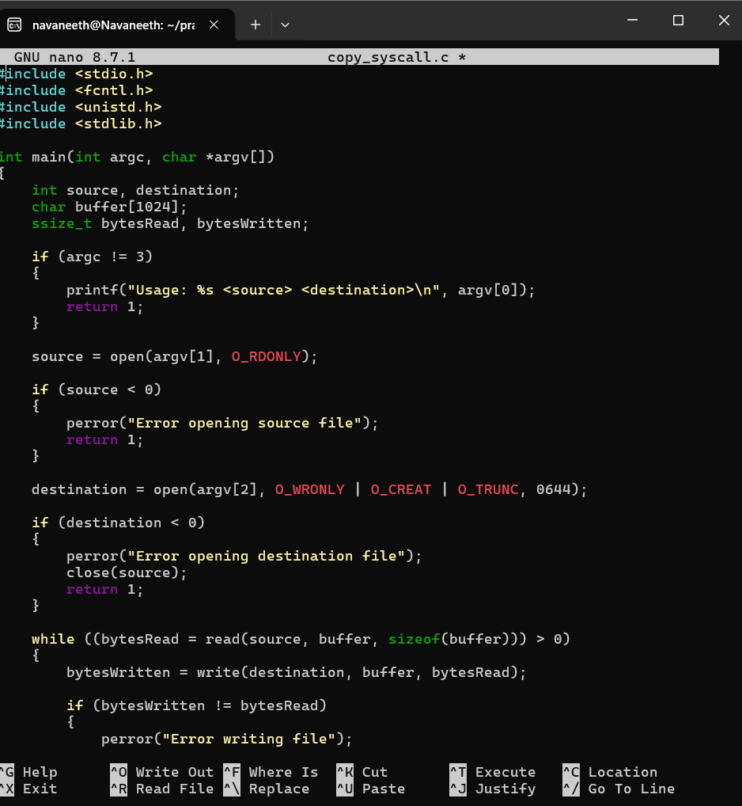
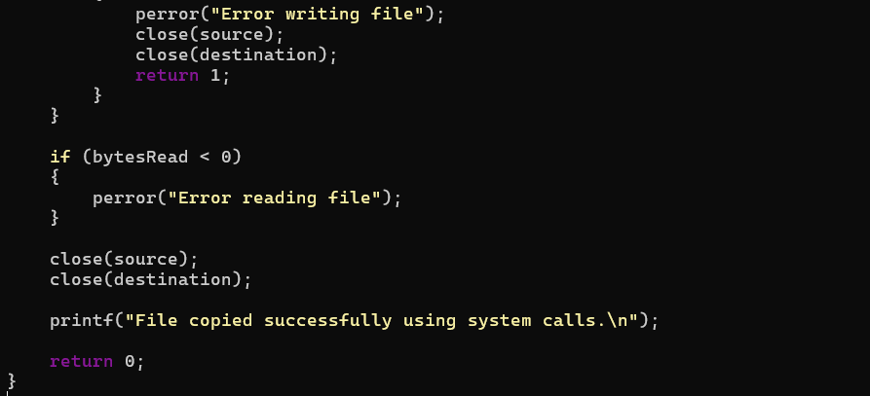
Output:
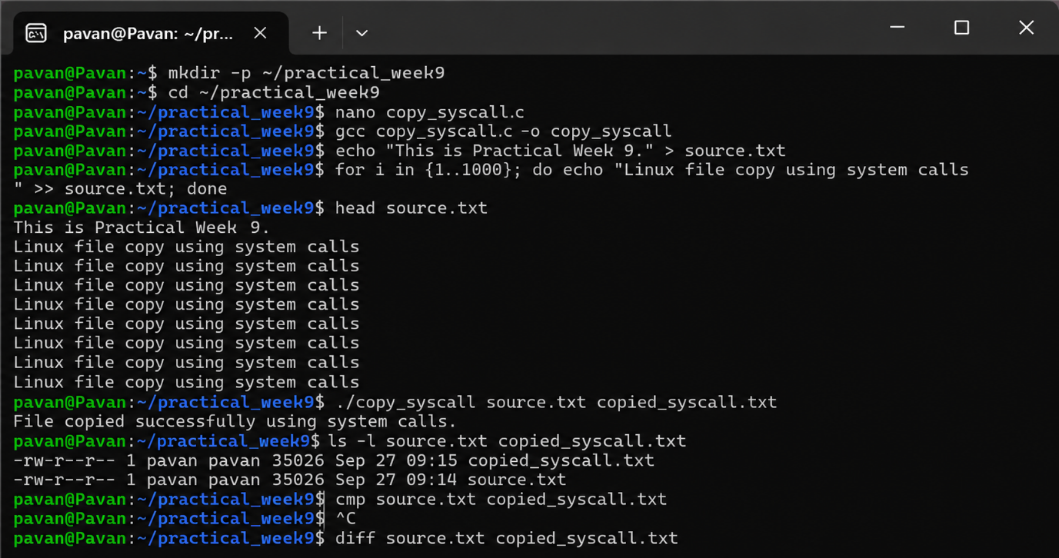

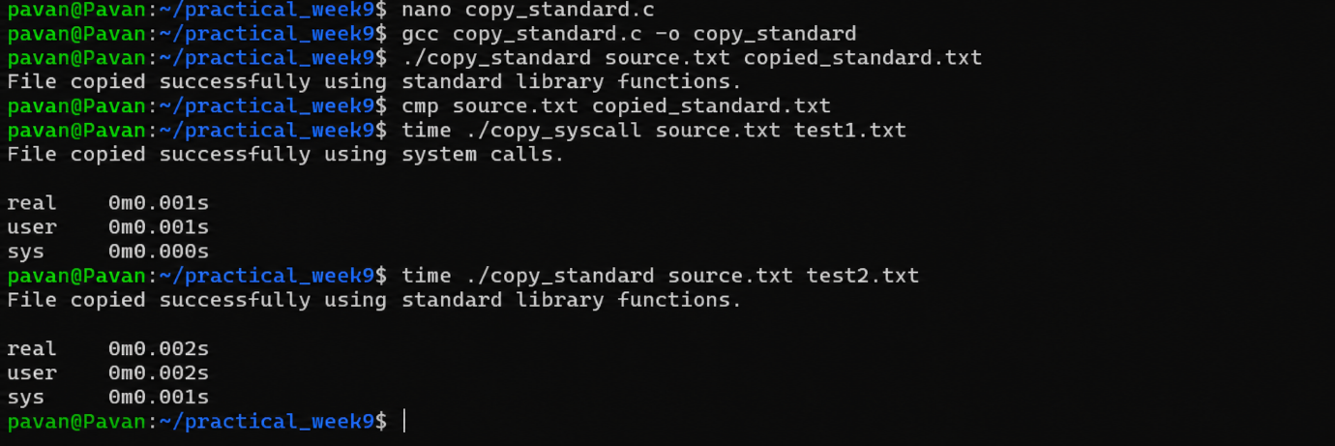
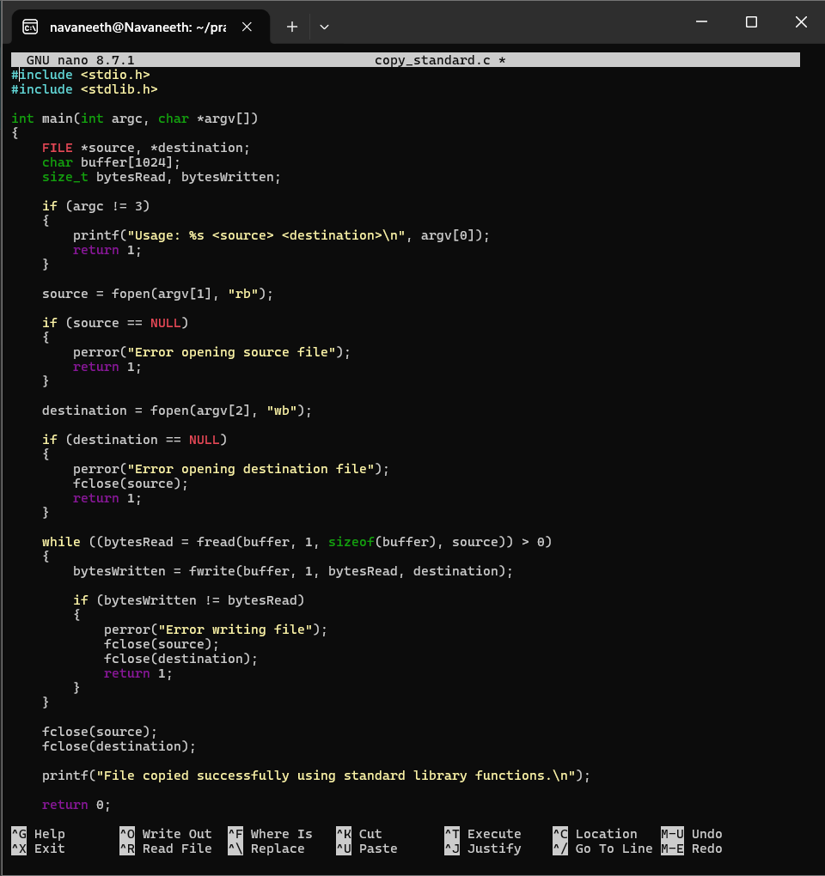

Observation
- open() opens the file.
- read() reads data from the source file.
- write() writes data to the destination file.
- close() closes the files.
- The standard library version uses fopen(), fread(), fwrite(), and fclose().
- Both programs successfully copy the file.
- cmp verifies that the copied files are identical.
- time can be used to compare their execution time.
Result
A file-copy utility was successfully implemented using low-level Linux system calls and compared with a standard C library implementation.
When you finish this, say next and we'll do Practical Week 9 – Question 2: Standard Input/Output Redirection using dup2().

Aim
To understand file descriptors and implement input and output redirection using the Linux dup2() system call.

Program:
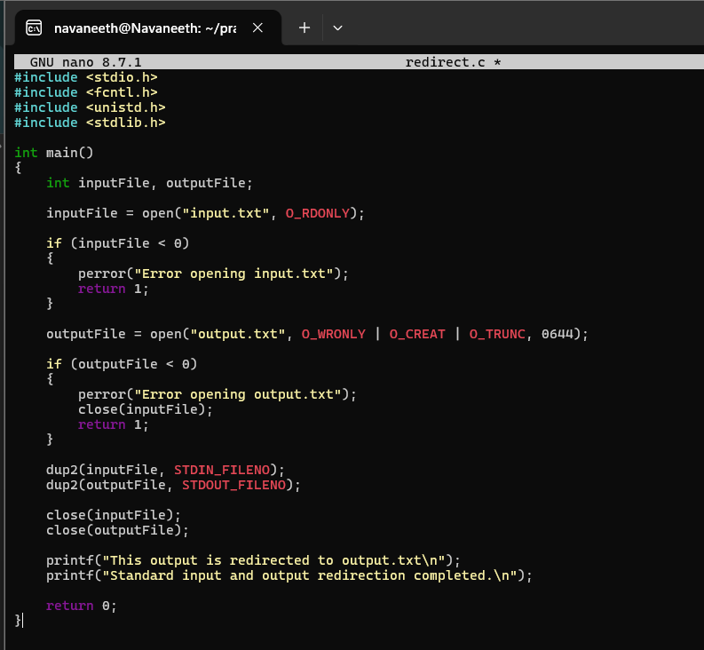
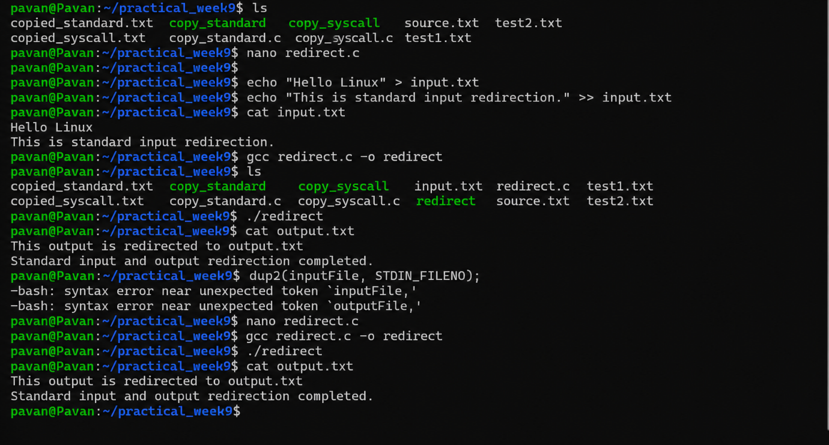

Final Result
File copying using low-level system calls, comparison with standard library functions, and standard I/O redirection using dup2() were successfully implemented and verified.

